**Eutrophication: why should humans care?**

1. **Introduction**

Eutrophication, or the introduction of excess materials into bodies of water, is a problem that exists worldwide. With a myriad of causes, eutrophication negatively affects many organisms, including plants, animals, and humans, and it is an obstacle in the way of at least 3 of the United Nations’ Sustainable Development Goals (UN SDGs, adopted in 2015 by all nations as part of the 2030 Agenda for Sustainable Development). With such dire consequences, one would think that considerable action has been taken to limit the effects of eutrophication; however, eutrophication is a relatively unspoken problem when compared to other environmental issues such as carbon dioxide emissions. In this paper, I will argue that eutrophication is a problem that needs to be addressed on a local and global scale not only due to its effects on worldwide ecosystems and plant and animal life but also due to its effects on humans. Then, I will propose several methods of eutrophication control and their potential real-world applications.

1. **Causes of Eutrophication**

While eutrophication is a problem that has existed for years and naturally occurs due to aging of aquatic systems and natural life cycles, including decomposition (Carpenter 1981), its occurrence has been accelerated in recent years. Current literature suggests that this is due to human activity, including dumping of sewage into aquatic ecosystems (LaPointe et al., 2015), fertilizer runoff (Huang et al., 2017), and excess animal waste and uneaten food from aquaculture (Talbot & Hole, 1994). In all of these cases, excess nutrients are being introduced into a body of water, and with human activity accelerating in recent years, many aquatic ecosystems are burdened with more nutrients than it can feasibly handle. Excess nutrients, therefore, lead to an array of adverse side effects, most notable being the increased growth and occurrence of algal blooms.

1. **Eutrophication Effects on Algae Growth**

Eutrophication typically accompanies an excessive growth of algae (Turner & Rabalais, 1994, Gilbert et al., 2005). This is due to eutrophication introducing nutrients that are essential for photosynthesis (Schindler, 2006), specifically nitrogen, phosphorus, and potassium (NPK). This leads to an algal bloom in the body of water, and many algal blooms give rise to negative effects, hence why the majority of algal blooms are known as harmful algal blooms (HABs). HABs are described as harmful due to a few significant negative effects: firstly, several species of algae produce toxins, which become fatal to the surrounding ecosystem due to their toxic nature (they are toxic to a variety of organisms) as well as potentially to humans who interact with them (Sellner et al., 2003, McCabe et al., 2016, Anderson et al., 2008). Secondly, the sheer biomass of the accumulated algae can alter ecosystems by shielding light and hindering water flow in various areas of an aquatic system (Gilbert et al., 2005); in fact, some severe HABs shield light on such a massive scale that the blooms can even be visible from outer space (Figure 1).

Another way in which HABs and other algal blooms alter ecosystems is by the creation of what are known as dead zones. Dead zones are areas of extremely low oxygen levels in the water, and algal blooms of all kinds promote these for one main reason: when the blooms decay, they enhance microbial activity in the bloom to decompose the organic matter, which consumes large amounts of oxygen (Diaz & Rosenberg, 2008, Joyce, 2000, Rabalais et al., 2002). Similar to eutrophic conditions, dead zones have been a natural occurrence for years (Rabalais et al., 2002), but the size and range of dead zones have been increasing in recent years (Rabalais et al., 2002, Dodds, 2006), particularly due to accelerated HAB growth.

It is important to note, however, that not all plant life is affected equally in eutrophic conditions. For example, seagrasses suffer from reduced numbers due to eutrophic conditions, and this is due to the effects of HABs, including toxicity and dead zones (Burkholder et al., 2007, LaPointe et al., 2015). Similarly, plants are not the only organisms that are affected negatively in eutrophic conditions; animals are as well.

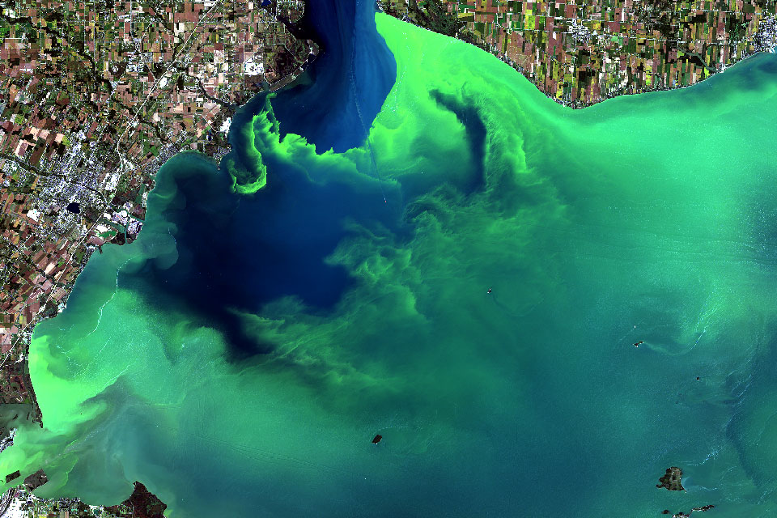

Figure 1: A harmful algal bloom (HAB) visible from space on September 26, 2017. The HAB stretched from Lake Erie (around Toledo, Ohio, USA) to Lake Ontario. The image was sourced from the National Oceanic and Atmospheric Administration (NOAA) via <https://oceanservice.noaa.gov/facts/hab-solutions.html>.

1. **Eutrophication Effects on Animal Growth**

Because of the effects of algal blooms, such as toxicity and dead zones, animals are generally greatly harmed in eutrophic environments. The first thing to note is that these harmful environments first lead to decreased numbers of organisms due to algal toxins killing organisms and dead zones suffocating organisms (Rosenberg, 1985, Carpenter, 2008, Correll, 1998, Karlson et al., 2002). This decreased number of organisms has impacts on complex food webs in aquatic ecosystems (Pimm et al., 1991, Pomeroy, 1974) - as numbers of one organism decrease, the numbers of others decrease or increase accordingly depending on the organism’s relationship with other organisms in the food web.

The other major problem eutrophication poses on animals is that eutrophication can lead to decreased biodiversity as well (Gilbert, 2017, Marques et al., 1997). For example, Lake Victoria, a lake that borders 5 African countries, has been subject to high levels of eutrophication (Hecky, 1993), and this, along with other human activities such as deforestation, has contributed to a decreased diversity in cichlids in the lake (Seehausen et al., 1997). A loss of biodiversity in any ecosystem has well-studied effects: it can lead to decreased biomass and sustainability of the ecosystem (Reich et al., 2012), it can slow the natural processes of the ecosystem, such as element cycling (Handa et al., 2014). A loss of biodiversity also affects humans in ways ranging from loss of food, medicines, and wood to unknown, complicated, and adverse effects (Duffy, 2003, Diaz et al., 2006). Because of this, biodiversity loss is of great concern to conservation ecologists, and since eutrophication can lead to a loss of biodiversity in aquatic ecosystems, it is no surprise that eutrophication is a major concern of conservationists as well.

On the other hand, eutrophication also poses a different problem in that some animals are able to thrive in eutrophic conditions (Pieczyńska et al., 1998). The current literature suggests that, as a general rule of thumb, benthic filter-feeding animals are able to thrive in eutrophic conditions (Officer et al., 1982). For example, *Macoma balthica*, a clam, was found to thrive in the Dutch Wadden Sea (Beukema & Cadée, 1986). This increase in numbers for certain species poses a problem in the form of biofouling, which refers to unwanted organisms accumulating on human structures (Bixler & Bhushan, 2012, Melo & Bott, 1997). Human activity has led to various structures being used in tandem with water systems, including cooling pipes, ships of all kinds, and hydropower plants, and the accumulation of biofouling organisms leads to non-optimal water flow. This poses a problem for structures that rely on water systems as these structures are designed with optimal water flow in mind; biofouling organisms obstruct water flow due to their sheer biomass, and thus their presence reduces the efficiency of the man-made structures on which they settle. Biofouling organisms, commonly referred to as biofoulers (Figure 2), are predicted to only become more prevalent in the future due to eutrophication (Nakano & Strayer, 2014).

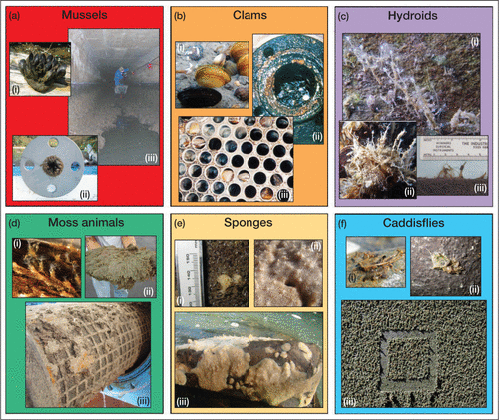

Figure 2 (previous): A figure from Nakano & Strayer (2014) detailing several common filter feeders that are also biofoulers of a variety of manmade structures, including intake pipes and ships. All of these organisms accumulate and obstruct water flow, preventing optimal function.

1. **Eutrophication Effects on Humans**

The aforementioned problems of algal blooms (decreased numbers of certain organisms, decreased biodiversity, and biofoulers) are obstacles to a variety of human activities, ranging from being unable to enjoy a day at the beach (Figure 3) to harming entire industries (Anderson et al., 2000, Prepas & Charette, 2003). As previously discussed, eutrophication can lead to an increased presence of toxins from algal blooms (Anderson et al., 2008), including neurotoxic shellfish poisons (NSPs) (Sellner et al., 2003) and domoic acid (McCabe et al., 2016), as well as decreased biodiversity in aquatic ecosystems, both of which harm aquatic organisms as well as humans that depend on them (Gilbert, 2017, Marques et al., 1997). The increased presence of toxins in water poses a risk to public health, significantly harms tourism rates, and requires more personnel to manage, leading to excess costs and lost revenue (Anderson et al., 2000), while the decreased biodiversity in aquatic ecosystems can, as stated previously, have various effects on humans (including loss of human needs such as food), some of which may not even be known (Duffy, 2003, Diaz et al., 2006).

However, the effects of eutrophication extend far beyond toxins in water and biodiversity loss. Most notably, the seafood industry, including commercial fishery and aquaculture, is at great risk of losses due to eutrophication (McCabe et al., 2016, Joyce, 2000, Prepas & Charette, 2003, Ferreira et al., 2007). This is mainly due to the previously discussed effect of eutrophication decreasing the numbers of organisms such as fish (Rosenberg, 1985). Anderson et al. (2000) estimated a loss of $18 million USD in commercial fisheries due to harmful algal blooms and eutrophication over the period of 1987-1992, or around $28 million USD in 2020. Through this, cultures and people groups that depend on seafood, especially those who live on islands or in coastal areas, are at greater risk of their way of life being restricted due to eutrophication.

On top of the seafood industry being harmed, many other industries and service providers are harmed by eutrophication as well, and this is mainly due to biofoulers being able to thrive in the presence of nutrients (Melo & Bott, 1997). As previously discussed, biofoulers tend to thrive in eutrophic conditions due to their filter-feeding nature (Officer et al., 1982, Beukema & Cadée, 1986). Biofoulers affect industries where water plays a critical role, from maritime operations (such as shipping) to the cooling of electric power plants (Bixler & Bhushan, 2012). Biofoulers can even inhabit water pipes for households. Nakano & Strayer (2014) estimated an additional cost of $277 million USD annually due to biofoulers in power plants and domestic water pipes, and they also predicted that since many biofoulers are filter-feeders, eutrophication would only increase their range.

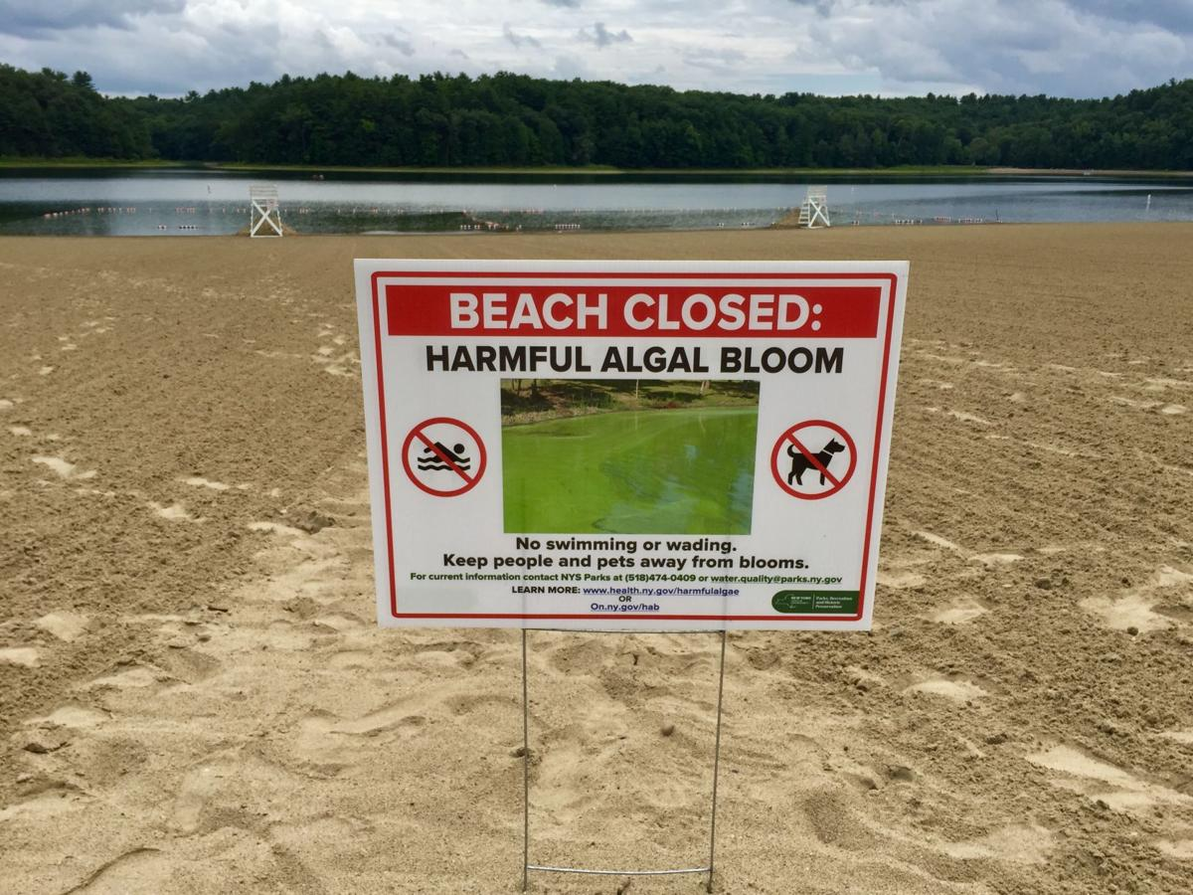

Figure 3 (previous): A sign at Moreau Lake State Park in Gansevoort, New York, USA informing visitors about the beach being closed due to a harmful algal bloom. Image was sourced from <https://poststar.com/news/local/state-reps-update-lake-associations-on-harmful-algal-blooms/article_c5b089b6-8670-5115-a1ce-15e2e459c880.html>.

1. **Controlling Eutrophication**

Despite the many harmful effects of eutrophication and a dire need to reduce its occurrence, there are solutions to lessen eutrophication. The main one relates to fertilizer, and Carpenter (2008) sites phosphorus control as a crucial step in the process. His solution is as follows: reduce the amount of phosphorus in the fertilizer applied to agricultural areas. To support his claim, he sites a 37-year experiment conducted by Schindler et al. (2008) to emphasize that while both nitrogen and phosphorus play a role in eutrophication, reducing nitrogen alone does not reduce algal blooms; therefore, it is even more critical that phosphorus usage be reduced. This has been done in several major bodies of water with favorable results, including Lake Ontario and Lake Erie (Schindler, 2012).

While phosphorus control is a proven, general counter to eutrophication, control measures specific to various ecosystems do exist and are sometimes preferable to phosphorus control (Correll, 1998). One of these control measures is the usage of filter-feeding organisms such as bivalves (Rice, 2001), and this has been used to control eutrophication in several applications, including aquaculture (Soto & Mena, 1999). However, the usage of organisms as a method of eutrophication control should be researched beforehand and monitored with caution, as they could escalate into a problem in the ecosystem in which they are used as well as in the surrounding ecosystems. If care is not taken when using organisms as a method of eutrophication control, there is a risk of an invasion of the organism in the nearby ecosystems, and this can lead to biofouling (Nakano & Strayer, 2014) as well as a loss of biodiversity in the surrounding ecosystems (Pyšek & Richardson, 2010). Biofouling and biodiversity loss are effects of eutrophication that we are trying to limit, so to use filter-feeding organisms can potentially solve one problem yet cause another equally disastrous one.

Above all, however, more research needs to be done in the area of eutrophication control, both in terms of general control methods (such as phosphorus control) and control for specific bodies of water. This is not only to improve the efficiency of eutrophication control methods, but it also can help to bridge the gap between people who may not find said control methods favorable, such as farmers who want to maximize crop output. Even though eutrophication may be a more and more widespread problem, it has its solutions just like any problem does.

1. **SUMMARY**

Eutrophication is a worldwide phenomenon that has been accelerated in recent years due to human activity such as fertilizer runoff. Because of this, the effects of eutrophication and the harmful algal blooms eutrophic conditions produce have become more pronounced. This has generally negative effects on plants and animals, but humans suffer some of the consequences as well, including excess cost for various industries such as the seafood industry. However, some animals, specifically benthic filter-feeders, are able to thrive in eutrophic conditions, but this creates an entirely different set of problems in the form of biofoulers. This myriad of harmful side effects only further stresses the need to take action, and while proven solutions do exist, such as phosphorus control, the main course of action that must be taken is to perform more research, whether it be on a single body of water or on a general eutrophication control mechanism.

1. **References**

Anderson, D. M., Hoagland, P., Kaoru, Y., & White, A. W. (2000). Estimated Annual Economic Impacts from Harmful Algal Blooms (HABs) in the United States. (Report No. WHOI-2000-11). U. S. National Oceanic and Atmospheric Administration.

Anderson, D. M., Burkholder, J. M., Cochlan, W. P., Gilbert, P. M., Gobler, C. J., Heil, C. A., Kudela, R. M., Parsons, M. L., Rensel, J. E. J., Townsend, D. W., Trainer, V. L., & Vargo, G. A. (2008). Harmful algal blooms and eutrophication: Examining linkages from selected coastal regions of the United States. *Harmful Algae, 8*, 39-53. doi:10.1016/j.hal.2008.08.017

Beukema, J. J., & Cadée, G. C. (1986). Zoobenthos responses to eutrophication of the Dutch Wadden Sea. *Ophelia, 26*, 55-64. doi:10.1080/00785326.1986.10421978

Bixler, G. D., & Bhushan, B. (2012). Biofouling: lessons from nature. *Philosophical Transactions of the Royal Society A: Mathematical, Physical and Engineering Sciences, 370*, 2381-2417. doi:10.1098/rsta.2011.0502

Burkholder, J. M., Tomasko, D. M., & Touchette, B. W. (2007). Seagrasses and eutrophication. *Journal of Experimental Marine Biology and Ecology, 350*, 46-72. doi:10.1016/j.jembe.2007.06.024

Carpenter, S. R. (1981). Submersed Vegetation: An Internal Factor in Lake Ecosystem Succession. *The American Naturalist, 118*, 372-383.

Carpenter, S. R. (2008). Phosphorus control is critical to mitigating eutrophication. Proceedings of the National Academy of Sciences, 105, 11039-11040. doi:10.1073/pnas.0806112105

Correll, D. L. (1998). The Role of Phosphorus in the Eutrophication of Receiving Waters: A Review. *Journal of Environmental Quality, 27,* 261-266. doi:10.2134/jeq1998.00472425002700020004x

Diaz, R. J., & Rosenberg, R. (2008). Spreading Dead Zones and Consequences for Marine Ecosystems. Science, 321, 926-929. doi:10.1126/science.1156401

Díaz, S., Fargione, J., Chapin III, F. S., & Tilman, D. (2006). Biodiversity Loss Threatens Human Well-Being. *PLOS Biology, 4,* e277. doi:10.1371/journal.pbio.0040277

Dodds, W. K. (2006). Nutrients and the “dead zone”: the link between nutrient ratios and dissolved oxygen in the northern Gulf of Mexico. *Frontiers in Ecology and the Environment, 4*, 211-217. doi:10.1890/1540-9295(2006)004[0211:NATDZT]2.0.CO;2

Duffy, J. E. (2003). Biodiversity loss, trophic skew and ecosystem functioning. *Ecology Letters, 6*, 680-687. doi:10.1046/j.1461-0248.2003.00494.x

Ferreira, J. G., Bricker, S. B., & Simas, T. C. (2007). Application and sensitivity testing of a eutrophication assessment method on coastal systems in the United States and European Union. Journal of Environmental Management, 82, 433-445. doi:10.1016/j.jenvman.2006.01.003

Gilbert, P. M. (2017). Eutrophication, harmful algae and biodiversity — Challenging paradigms in a world of complex nutrient changes. *Marine Pollution Bulletin, 124*, 591-606. doi:10.1016/j.marpolbul.2017.04.027

Gilbert, P., Seitzinger, S., Heil, C., Burkholder, J., Parrow, M., Codispoti, L., & Kelly, V. (2005). The Role of Eutrophication in the Global Proliferation of Harmful Algal Blooms. *Oceanography, 18,* 198-209. doi:10.5670/oceanog.2005.54

Handa, I. T., Aerts, R., Berendse, F., Berg, M. P., Bruder, A., Butenschoen, O., Chauvet, E., Gessner, M. O., Jabiol, J., Makkonen, M., McKie, B. G., Malmqvist, B., Peters, E. T. H. M., Scheu, S., Schmid, B., van Ruijven, J., Vos, V. C. A., Hättenschwiler, S. (2014). Consequences of biodiversity loss for litter decomposition across biomes. *Nature, 509*, 218-221. doi:10.1038/nature13247

Hecky, R. E. (1993). The eutrophication of Lake Victoria. *SIL Proceedings, 1922-2010, 25,* 39-48. doi:10.1080/03680770.1992.11900057

Huang, J., Xu, C.-C., Ridoutt, B. G., Wang, X.-C., & Ren, P.-A. (2017). Nitrogen and phosphorus losses and eutrophication potential associated with fertilizer application to cropland in China. *Journal of Cleaner Production, 159*, 171-179. doi:10.1016/j.jclepro.2017.05.008

Joyce, S. (2000). The dead zones: oxygen-starved coastal waters. *Environmental Health Perspectives, 108*, A120-A125. doi:10.1289/ehp.108-a120

Karlson, K., Rosenberg, R., & Bonsdorff, E. (2002). Temporal and spatial large-scale effects of eutrophication and oxygen deficiency on benthic fauna in Scandinavian and Baltic waters: a review. *Oceanography and Marine Biology: An Annual Review, 40*, 427-489.

LaPointe, B. E., Herren, L. W., Debortoli, D. D., & Vogel, M. A. (2015). Evidence of sewage-driven eutrophication and harmful algal blooms in Florida's Indian River Lagoon. *Harmful Algae, 43*, 82-102. doi:10.1016/j.hal.2015.01.004

Marques, J. C., Pardal, M. Â., Nielsen, S. N., & Jørgensen, S. E. (1997). Analysis of the properties of exergy and biodiversity along an estuarine gradient of eutrophication. *Ecological Modelling, 102*, 155-167.

Melo, L. F., & Bott, T. R. (1997). Biofouling in water systems. *Experimental Thermal and Fluid Science, 14*, 375-381. doi:10.1016/S0894-1777(96)00139-2

McCabe, R. M., Hickey, B. M., Kudela, R. M., Lefebvre, K. A., Adams, N. G., Bill, B. D., Gulland, F. M. D., Thomson, R. E., Chochlan, W. P., & Trainer, V. L. (2016). An unprecedented coastwide toxic algal bloom linked to anomalous ocean conditions. *Geophysical Research Letters, 43*, 10366-10376. doi:10.1002/2016GL070023

Nakano, D., & Strayer, D. L. (2014). Biofouling animals in fresh water: biology, impacts, and ecosystem engineering. *Frontiers in Ecology and the Environment, 12,* 167-175. doi:10.1890/130071

Officer, C. B., Smayda, T. J., & Mann, R. (1982). Benthic Filter Feeding: A Natural Eutrophication Control. *Marine Ecology Progress Series, 9*, 203-210. doi:10.3354/meps009203

Pieczyńska, E., Kołodziejczyk, A., & Rybak, J. I. (1998). The responses of littoral invertebrates to eutrophication-linked changes in plant communities. *Hydrobiologia, 391*, 9-21. doi:10.1023/A:1003503731720

Pimm, S. L., Lawton, J. H., & Cohen, J. E. (1991). Food web patterns and their consequences. *Nature, 350*, 669-674. doi:10.1038/350669a0

Pomeroy, L. R. (1974). The Ocean's Food Web, A Changing Paradigm. *BioScience, 24*, 499-504. doi:10.2307/1296885

Prepas, E. E., & Charette, T. (2003). Worldwide Eutrophication of Water Bodies: Causes, Concerns, Controls. Treatise on *Geochemistry, 9*, 311-331. doi:10.1016/B0-08-043751-6/09169-6

Pyšek, P., & Richardson, D. M. (2010). Invasive Species, Environmental Change and Management, and Health. *Annual Review of Environment and Resources, 35*, 25-55. doi:10.1146/annurev-environ-033009-095548

Rabalais, N. N., Turner, R. E., & Wiseman, W. J. (2002). Gulf of Mexico Hypoxia, A.K.A. “The Dead Zone”. *Annual Review of Ecology and Systematics, 33*, 235-263. doi:10.1146/annurev.ecolsys.33.010802.150513

Reich, P. B., Tilman, D., Isbell, F., Mueller, K., Hobbie, S. E., Flynn, D. F. B., & Eisenhauer, N. (2012). Impacts of Biodiversity Loss Escalate Through Time as Redundancy Fades. *Science, 336*, 589-592. doi:10.1126/science.1217909

Rice, M. (2001). Environmental Impacts of Shellfish Aquaculture: Filter Feeding to Control Eutrophication. Marine Aquaculture and the Marine Environment: A Meeting for the Stakeholders in the Northeast, University of Massachusetts, Boston, January 2001. Falmouth, MA: Cape Cod Press.

Rosenberg, R. (1985). Eutrophication—The future marine coastal nuisance? *Marine Pollution Bulletin, 16*, 227-231. doi:10.1016/0025-326X(85)90505-3

Schindler, D. W. (2006). Recent advances in the understanding and management of eutrophication. *Limnology and Oceanography, 51*, 356-363. doi:10.4319/lo.2006.51.1_part_2.0356

Schindler, D. W. (2012). The dilemma of controlling cultural eutrophication of lakes. *Proceedings of the Royal Society B: Biological Sciences, 279*, 4322-4333. doi:10.1098/rspb.2012.1032

Seehausen, O., van Almphen, J. J. M., & Witte, F. (1997). Cichlid Fish Diversity Threatened by Eutrophication That Curbs Sexual Selection. *Science, 277,* 1808-1811. doi:10.1126/science.277.5333.1808

Sellner, K. G., Doucette, G. J., & Kirkpatrick, G. J. (2003). Harmful algal blooms: causes, impacts and detection. *Journal of Industrial Microbiology and Biotechnology, 30*, 383-406. doi:10.1007/s10295-003-0074-9

Soto, D., & Mena, G. (1999). Filter feeding by the freshwater mussel, *Diplodon chilensis*, as a biocontrol of salmon farming eutrophication. *Aquaculture, 171,* 65-81. doi:10.1016/S0044-8486(98)00420-7

Talbot, C., & Hole, R. (1994). Fish diets and the control of eutrophication resulting from aquaculture. *Journal of Applied Ichthyology, 10*, 258-270. doi:10.1111/j.1439-0426.1994.tb00165.x

Turner, R. E., & Rabalais, N. N. (1994). Coastal eutrophication near the Mississippi River delta. *Nature, 368,* 619-621. doi:10.1038/368619a0